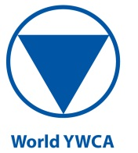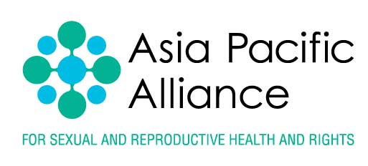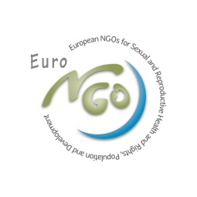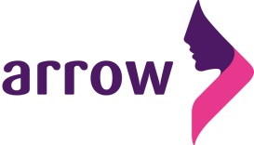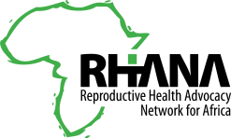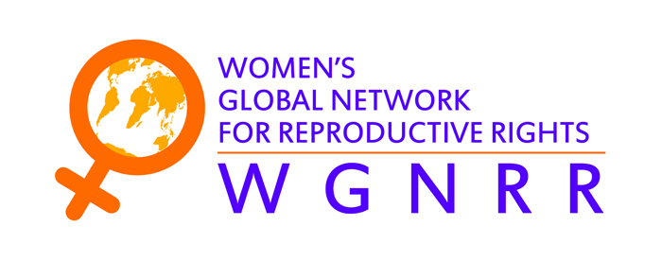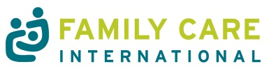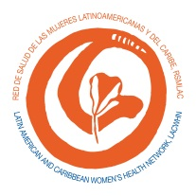

1 October, 2014

Dear Mr Secretary-General,

We are writing to you as the Coordinating Committee of the Civil Society Platform to Promote Sexual and Reproductive Health and Rights (SRHR) Beyond 2015, a global advocacy initiative uniting 12 SRHR networks representing over 2,000 nongovernmental organizations worldwide.

During the past 18 months, we have closely followed the processes contributing to defining the post-2015 development agenda, including the General Assembly Open Working Group which agreed the proposed sustainable development goals and targets, as included in its report. In the areas of sexual and reproductive health and rights, these goals and targets have clearly built on the consensus agreed in the Rio + 20 outcome document *The Future We Want* and the Agreed conclusions of the 58th session of the Commission on the Status of Women, held in March 2014.

We are pleased that the importance of ensuring sexual and reproductive health and reproductive rights for all in order to achieve sustainable development is included in the proposed sustainable development goals and targets under both the health goal and the gender equality goal. However, we would have preferred the sustainable development goals and targets to reflect the full recognition of sexual and reproductive health and rights as in, for example, the *Montevideo Consensus* and other outcomes of the regional conferences for the ICPD Beyond 2014 review process. Nevertheless, we feel that the current proposed goals and targets are an important first step.

We strongly urge you to address sexual and reproductive health and rights in the synthesis report and to ensure, as a bare minimum, that the outcomes of the Open Working Group report related to sexual and reproductive health and reproductive rights under both the health and gender equality goals are also fully included in your synthesis report, which will support the development of the post-2015 development agenda. We also request that you give high consideration in the synthesis report to even greater emphasis on a human rights-based approach to the post-2015 development agenda and to including young people more centrally, as called for in the *Colombo Declaration* and at the ECOSOC Youth Forum.

As organizations that work in service delivery as well as advocacy, we have carefully considered the Report of the Open Working Group with its 17 goals that encompass the broad spectrum of sustainable development. We do not find the number of goals to be excessive given the concerns that must be addressed during the next 15 years. We therefore urge you to support the goals as included in the Open Working Group report; we believe that they are all necessary if we are to leave no one behind in the post-2015 development agenda.

We look forward to working with you and with all member states to define a post-2015 development agenda that fulfills the right of all people to live healthy and productive lives, including through ensuring universal access to sexual and reproductive health and rights.

Yours sincerely,

Alison Marchall, International Planned Parenthood Federation (IPPF)

Amy Boldosser, Family Care International (FCI) – on behalf of North America

Ana Rizescu, YouAct

Dinah Musindarwezo, Reproductive Health Advocacy Network of Africa (RHANA)

Hendrica Okondo, World Young Women Christian Association (WYWCA)

Kathy Mulville, Woman’s Global Network for Reproductive Rights (WGNRR)

Marta Szostak,  ASTRA – Central and Eastern European Women’s Network for Sexual and Reproductive Health and Rights

Sandra Castaneda, Latin American and Caribbean Woman’s Health Network (LACWHN)

Siva Thanenthiran, Asian-Pacific Resource & Research Centre for Women (ARROW)

Yvonne Bogaarts, EuroNGOs – the European NGOs for Sexual and Reproductive Health and Rights, Population and Development

cc

Ms Amina J Mohammed, Special Adviser to the UN Secretary-General on Post-2015 Development Planning

Mr Jan Eliasson, Deputy Secretary-General

Mr Thomas Gass, Assistant Secretary-General for Policy Coordination and Inter-Agency Affairs