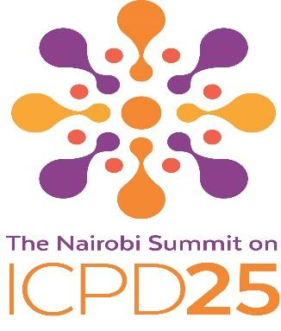

International Steering Committee

Partners | Name | Designation | Country (Based in) | Regions
Youth and young people

1 | Ms. Jayathma Wickramanayake | Envoy of the Secretary-General on Youth | US | Global
2 | Ms. Aya Chebbi | Youth Envoy for the African Union | Tunisia | Africa
3 | Mr. Yemurai Nyoni | Youth fellow on policy and advocacy, CIFF | Zimbabwe | Global
Parliamentarians

1 | Dame Billie Miller | Retired politician | Barbados | Caribbean
2 | Hon. Fahmi Fadzil | Member of Parliament | Malaysia | Asia and the Pacific
3 | Senator Catherine Noone | Senator | Ireland | Europe
4 | Mr. Neil Datta | Executive Director, European Parliamentary Forum | Belgium | Europe
Civil society

1 | Ms. Naisola Likimani | SheDecides Secretariat | UK | Global
2 | Mr. Alvaro Bermejo | Executive Director, IPPF | UK | Global
3 | Mr. Ton Coenen | Executive Director - Rutgers, Chair - INSPIRE | The Netherlands | Europe
4 | Ms. Nesime Salioska | Roma advocate | North Macedonia | Europe
5 | Dr. Ana Cristina Gonzalez Velez | Medical doctor and expert in gender, human rights, sexual and reproductive health | Colombia | Latin America
6 | Ms. Shireen Jejeebhoy | Director Aksha and Vice President - IUSSP | India | Asia and the Pacific
7 | Rev. James Bhagwan | General Secretary – Pacific Conference of Churches, and member of G20 Interfaith Forum | Fiji | Asia and the Pacific
8 | Ms. Jackie Edmond | Chief Executive, Family Planning Association | New Zealand | Asia and the Pacific
9 | Ms. Jill Sheffield | Past president, Women Deliver | US | North America
Non-traditional Partners, Private Sector, Philanthropies

1 | Ms. Akiko Nakajo | Head of Google-Japan | Japan | Asia and the Pacific
2 | Ms. Theo Sowa | CEO, African Women’s Development Fund | Ghana | Africa
Academia and Research Institutes

1 | Mr. Gamal Serour | Director, International Islamic Center for Population Studies, Al-Azhar University, Cairo | Egypt | Africa
2 | Dr. Leith Dunn | Senior Lecturer/Head of the University of the West Indies' Institute for Gender and Development Studies Mona Unit | Jamaica | Caribbean
3 | Dr. Nisia T. Lima | President of Fiocruz | Brazil | Latin America
Foundations and philanthropy

1 | Mr. Josh Lozman | BMGF | US | North America
2 | Ms. Senait Fisseha | Director, International Programs, Susan Buffett Foundation | US | North America
3 | Ms. Kathy Calvin | President/CEO, UN Foundation | US | North America
4 | Ms. Toyin Saraki | Founder/President, Wellbeing Foundation | Nigeria | Africa
Member States – Regional review leads

1 | H.E. Mr. Georgy Panayotov | PR of Bulgaria to UN | US
2 | H.E. Mr. Mohamed Fathi Ahmed Edrees | Ambassador of Egypt to UN | US
3 | H.E. Mr. Gustavo Adolfo Meza-Cuadra Velasquez | PR of Peru to UN | US
4 | H.E. Dr. Francis Mustapha Kai-Kai | PR of Sierra Leone to UN | US
5 | H.E. Ms. Sima Sami Bahous | PR of Jordan to UN | US
6 | H.E. Ms. Kira Christianne D. Azucena | Charge de’ affaires, a.i. of Philippines to UN | US

